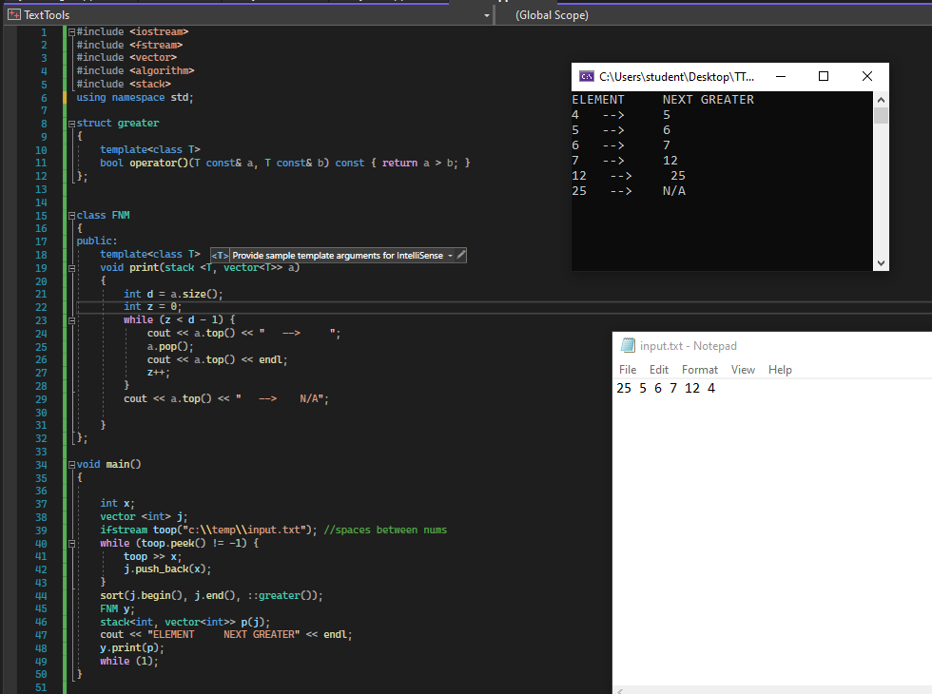#include <iostream>

#include <fstream>

#include <vector>

#include <algorithm>

#include <stack>

using namespace std;

struct greater

{

template<class T>

bool operator()(T const& a, T const& b) const { return a > b; }

};

class FNM

{

public:

template<class T>

void print(stack <T, vector<T>> a)

{

int d = a.size();

int z = 0;

while (z < d - 1) {

cout << a.top() << " --> ";

a.pop();

cout << a.top() << endl;

z++;

}

cout << a.top() << " --> N/A";

}

};

void main()

{

int x;

vector <int> j;

ifstream toop("c:\\temp\\input.txt"); //spaces between nums

while (toop.peek() != -1) {

toop >> x;

j.push_back(x);

}

sort(j.begin(), j.end(), ::greater());

FNM y;

stack<int, vector<int>> p(j);

cout << "ELEMENT NEXT GREATER" << endl;

y.print(p);

while (1);

}